**Sequence Diagram:**

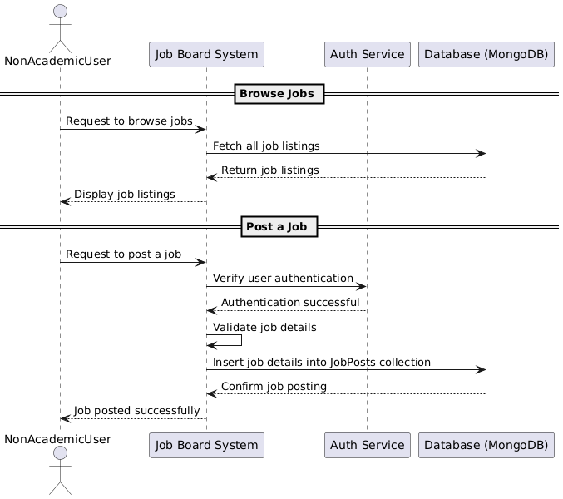

**Database:**

**Functional Requirements**

1. Non-academic users must be able to browse job listings.
2. Job listings should be retrieved from MongoDB and displayed.
3. Non-academic users must be able to post job openings.
4. The system should validate job details before saving them.
5. Users should be notified of successful job postings.

**Non-Functional Requirements**

* 1. **Performance –** Queries should execute in under 2 seconds.
  2. **Scalability –** The system should support an increasing number of job listings.
  3. **Security –** Users must be authenticated before posting jobs**.**
  4. **Usability –** The interface should be simple for job browsing and posting.
  5. **Reliability –** Jobs should not be lost and must persist in the database.